NATHAN BARTON ELEMENTARY SCHOOL
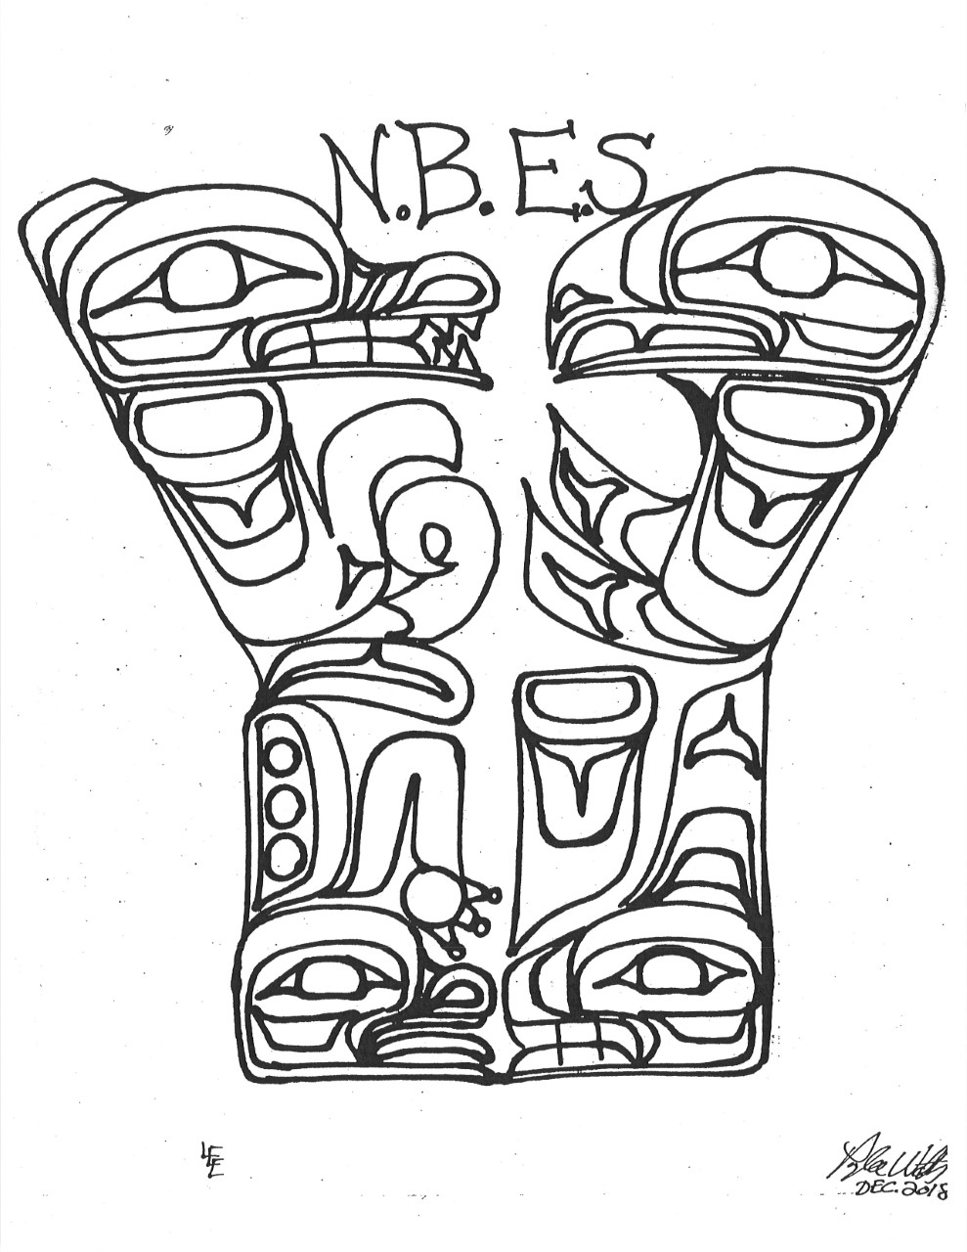
Ms. Rosetta Doolan, Principal Email rdoolan@nisgaa.bc.ca
1310 Volunteer
General Delivery Telephone (250) 326-4206 ext.1702
Gingolx, BC V0V 1B0 Facsimile (250) 326-4252

2026/27 NBES School Supply List: Grade 3/4/5

- 1 - Backpack
- 1 - Pair indoor shoes - NO BLACK SOLES
- 1 – Rain Jacket & gum boots for outdoor learning
- 1 – clear water bottle
- 2 – packs facial tissue
- 1 - Artist portfolio (big enough to hold art projects)
- 1 - 100 page Artist sketchbook, heavy paper
- Package tracing paper
- 2 packs– Hilroy Exercise note books (blue/pink/yellow/green)
- 2 - Bottle liquid glue
- 6- large glue sticks
- 1 - Ruler with mm, cm 30cm
- 1 - Box 24 crayons
- 1-pack non-scented markers
- 1 - box of pencil crayons
- 1 - Package oil pastels
- 1 - Paint brush kit
- 1 - Scissors
- 60 - #2 HB pencils
- 10 - Erasers
- 1 - Round Pencil Sharpener
- 1 - Math geometry set
- 1 - basic handheld calculator
- 6 - Highlighters
- 1 - Headphones
- 1 - Package of Dry Erasers Markers
- 1 - Dry Erase Brush

***NBES is a scent-free school, therefore scented markers are prohibited***

NATHAN BARTON ELEMENTARY SCHOOL
Ms. Rosetta Doolan, Principal Email rdoolan@nisgaa.bc.ca
1310 Volunteer
General Delivery Telephone (250) 326-4206 ext.1702
Gingolx, BC V0V 1B0 Facsimile (250) 326-4252

2026/27 NBES School Supply List: Grade 6 & 7

- 1 - Backpack
- 1 - Pair indoor shoes - NO BLACK SOLES
- 1 – clear water bottle
- 1 – Rain Jacket & gum boots for outdoor learning
- 2 – packs facial tissue
- 4 - Duo tangs
- 2 - Packages loose leaf paper - LINED
- 3 - Packages loose leaf paper - PLAINWHITE
- 1 - Package loose leaf paper - GRAPH ¼
- 6 - Erasers
- 4 - Permanent markers - assorted colors
- 3 – packs hilroy lined exercise books (
- 6 - Large glue sticks
- 1 - Liquid glue bottle
- 1 – artist sketch book (heavy)
- 1 - Artist portfolio (big enough to hold art projects)
- 1 – Pencil case
- 1 - Box 24 #2 HB pencils with eraser
- 1 - Drawing Pencil - B, 2B, 3B, 4B
- 1 - Package 24 colored pencils
- 1- package non-scented markers
- 1 - Package 12 watercolor pencils
- 1 – pack oil pastels
- 6 - Highlighters
- 1- package of watercolor tubes - 12 colors
- 1 - Each watercolor brushes - soft, round size 1", 6", 10" size 4" FLAT
- 1 – pack variety paint brushes

***NBES is a scent-free school, therefore scented markers are prohibited***

NATHAN BARTON ELEMENTARY SCHOOL
Ms. Rosetta Doolan, Principal Email rdoolan@nisgaa.bc.ca
1310 Volunteer
General Delivery Telephone (250) 326-4206 ext.1702
Gingolx, BC V0V 1B0 Facsimile (250) 326-4252

2026/27 School Supply List: Kindergarten, Grade 1 & 2

- 1-back pack
- 1 - Pair indoor shoes, NO BLACK SOLES
- 1 – Small clear water bottle
- 1 – Rain Jacket & gum boots for outdoor learning
- 2 - packs facial tissue
- 1 - Artist portfolio (big enough to hold art projects)
- 1 - 50 page Artist sketchbook
- 6- duotangs
- 6 – Hilroy Exercise notebooks (1/2 plain/1/2 ruled – yellow book)
- 4 – Hilroy Exercise notebooks (Plain-Blue book)
- 4-Hilroy Stitched Exercise books- (Blue)
- 2 - Bottle liquid glue
- 4- large glue sticks
- 1 - Ruler with mm, cm 30cm
- 1 - Box 24 crayons
- 1-box unscented markers
- 1 - box of pencil crayons
- 1-paint brush set
- 1 - Scissors
- 60 - #2 HB pencils
- 2 pencil boxes
- 1 - Package 12 tempera paints
- 1 - Package oil pastels
- 6 - Erasers
- 1 - Round Pencil Sharpener
- 1 - Headphones
- 1 - Package of Dry Erasers Markers
- 1 - Dry Erase Brush
- 1 – pack printer white paper -regular letter size

***NBES is a scent-free school, therefore scented markers are prohibited***

